#### 

#### IMPLEMENTATION

Following hardware and software requirements have been fulfilled for the project:

Any Laptop/PC with a good working Web camera. Basic Computer Specifications:

* + Operating System: Windows 10 /11
  + Language: Python
  + IDE: PyCharm, MySQL Workbench
  + RAM: 4GB RAM (MINIMUM)
  + HDD: 80 GB HDD / 110 GB SSD (MINIMUM)

#### SOFTWARE REQUIREMENTS:

Any Laptop/PC with:

* + - **Python IDLE** or **PyCharm** to execute the entire program
    - **MySQL Workbench** for database
    - **MySQL Connector** for connectivity

#### HARDWARE REQUIREMENTS:

* + - RAM: **4GB RAM** (MINIMUM)
    - HDD: **80 GB HDD / 110 GB SSD** (MINIMUM)
    - PROCESSOR: **Dual Core Processor**
    - OPERATING SYSTEM: **Microsoft Windows 10/11**

#### SETUP STEPS:

#### Install and setup Python from <https://www.python.org/downloads/> and also add it to path in your system in environment variables.

#### Install and setup Pycharm.

#### Install and setup MySQL Workbench and MySQL Connector for connectivity; while setting up MySQL Workbench set the password for root as “Harsha@989” (Whatever password is set same is to be written on student.py file, line 383 for connectivity)

#### Open Command prompt and all the python modules as:

#### pip install numpy

#### pip install pandas

#### pip install matplotlib

#### pip install Pillow

#### pip install datetime

#### pip install tk

#### pip install opencv-contrib-python

#### pip install opencv-python

#### pip install mysql-connector-python

#### Now copy the whole project folder named “project” in your desktop.

#### Now open the all the .py file in pycharm.

#### To run the project, set the pycharm interpreter as:

#### 

#### From the Pycharm setting>Project:main.py>Python Interpreter.

#### Now, run the main.py file. Upon running the main interface of the project will open like the following fig.1

#### Fig.1.: The main interface

1. On Clicking, Student details button we will get the interface as shown in Fig.2. below wherein one can fill the student details.

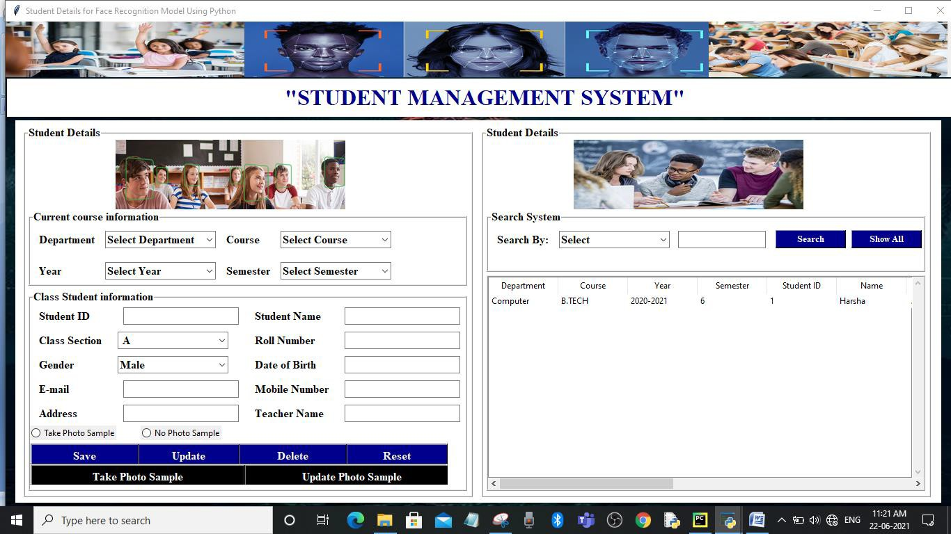

Fig.2.: Filling Student Details

After filling details, we can save it and take photos samples by clicking on Take Photo Sample (Black Button) as in Fig.2.1:

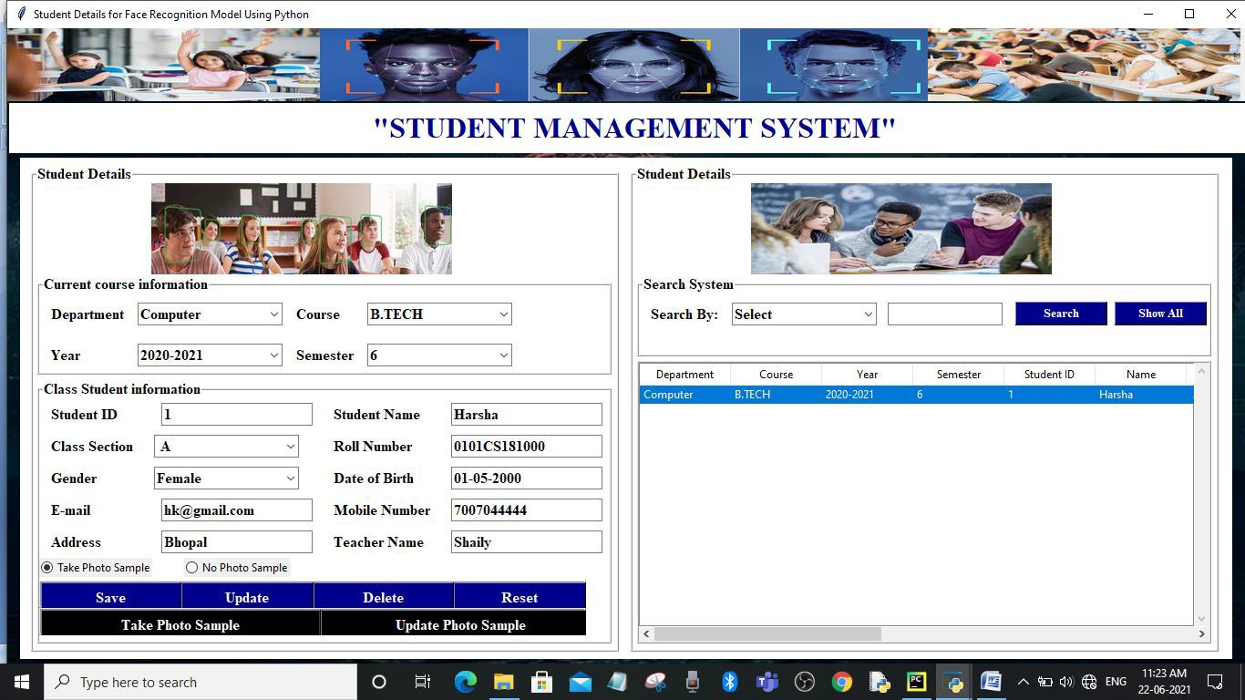

Fig.2.1.: Taking Photo Sample Button

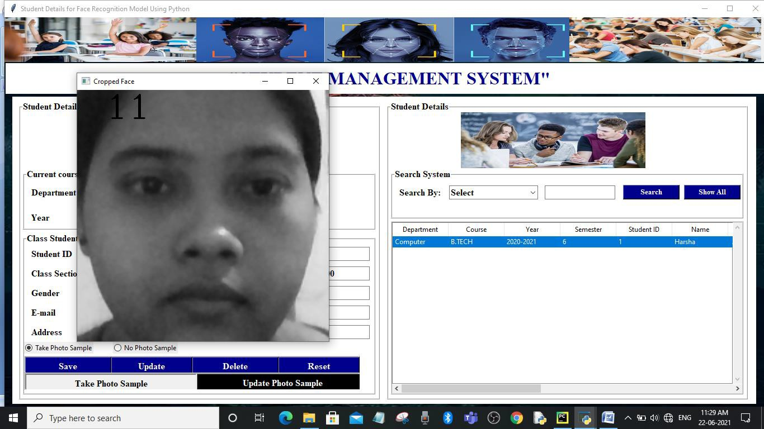

Fig. 2.2.: Capturing Images of The Student

After clicking enough photo samples, you can exit by pressing enter key. If not pressed enter key “System” will take 100 Photo samples as shown in Fig.2.2. On Completion of the image capturing, the message “Generating data sets completed!!!” will be shown on the screen as shown in the Fig.2.3.

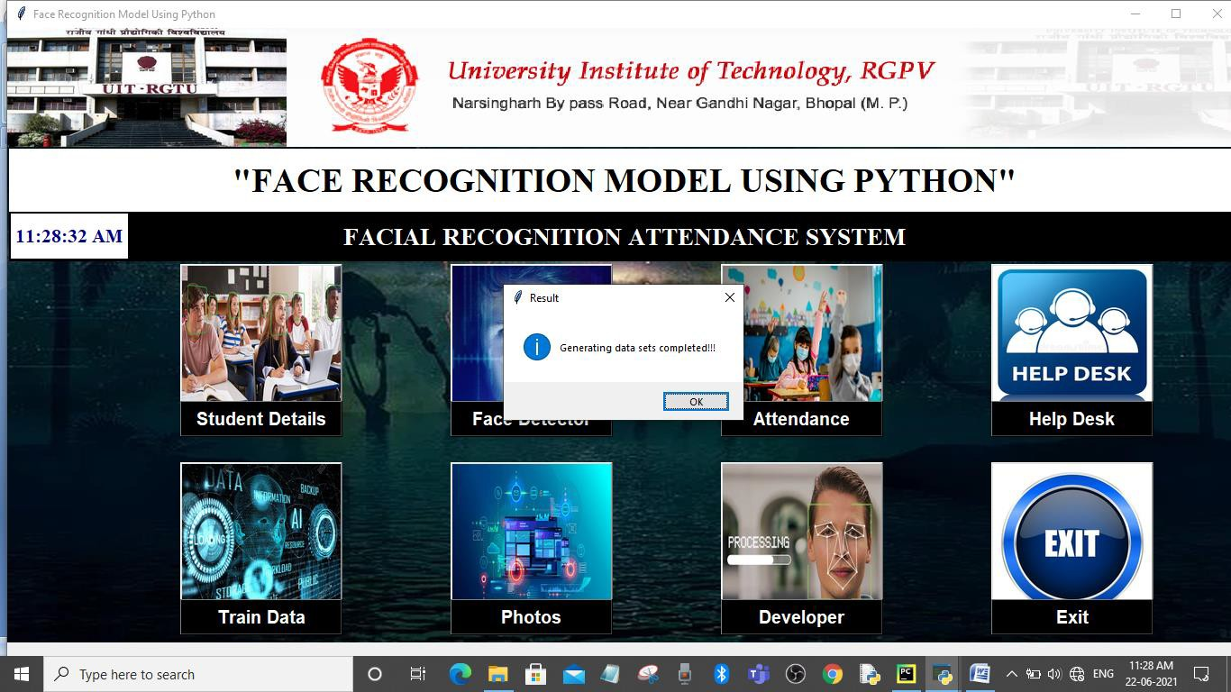

Fig.2.3.: Capturing Data Sets Done

Even after saving we can update, delete and also reset the student details. We can update by selecting the data and changing it and finally clicking on update button. Then system will ask whether we want to update or not. If we are sure we can click yes.

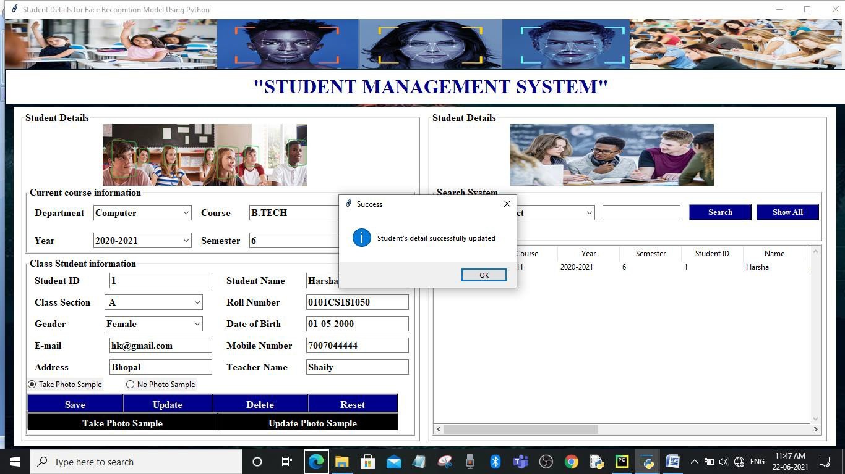After clicking Yes, the message “Student’s detail successfully updated” will appear;

Fig.2.4.: Successfully Updated

We can look the list of students along with their details completely available in the right-hand side table that is associated with the database as shown in Fig.2.5.

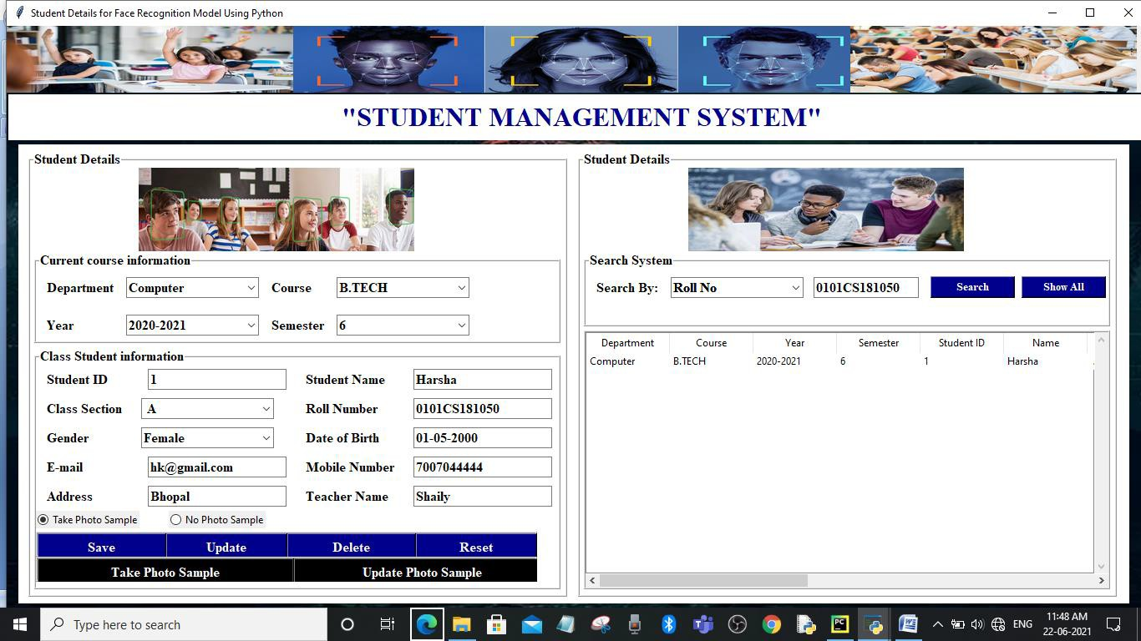

Fig. 2.5.: Data Fed Visible on Right Hand Side

Now clicking on the Train Data Button on the main interface. Click on Train Data for training the data. After clicking on Train data, we will see the below interface as shown in the Fig.3.:

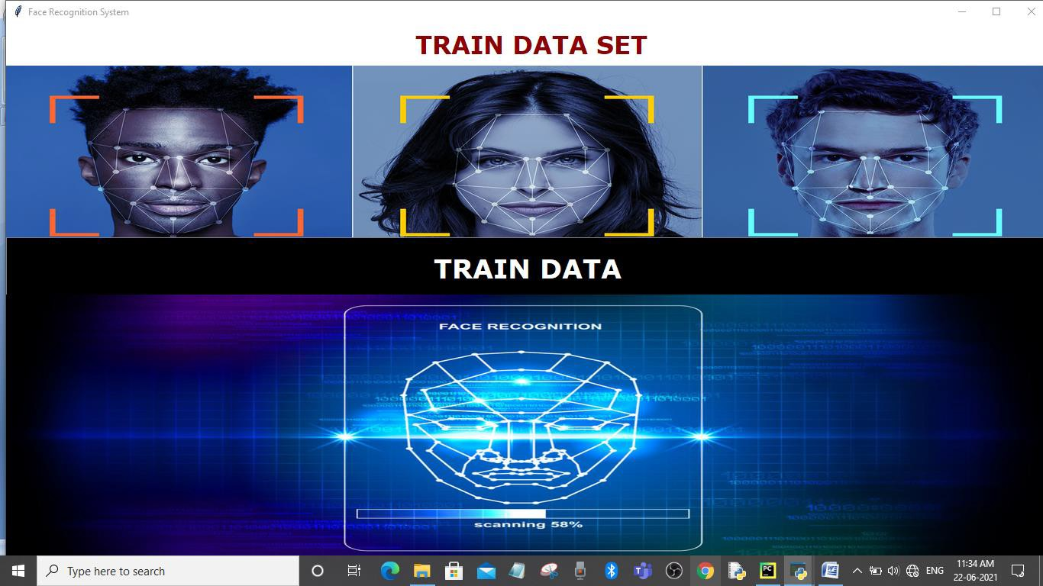

**Fig.3.: Training Data Interface**

Here clicking on TRAIN DATA, we can train the images taken before as shown in the Fig.3.1.

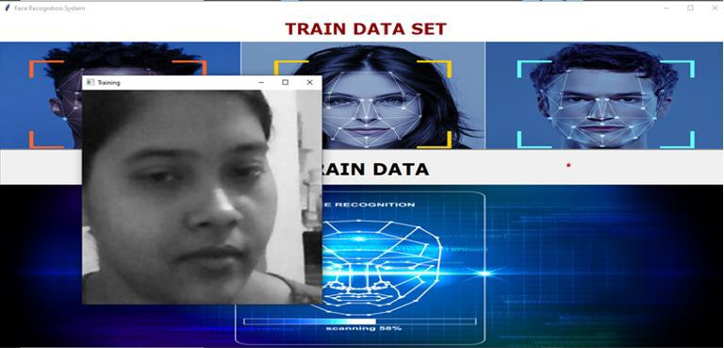

Fig.6.3.1.: Training Data Sets

When training Data Sets will be completed, the message “Training data sets completed” will be displayed as shown in the Fig.3.2.:

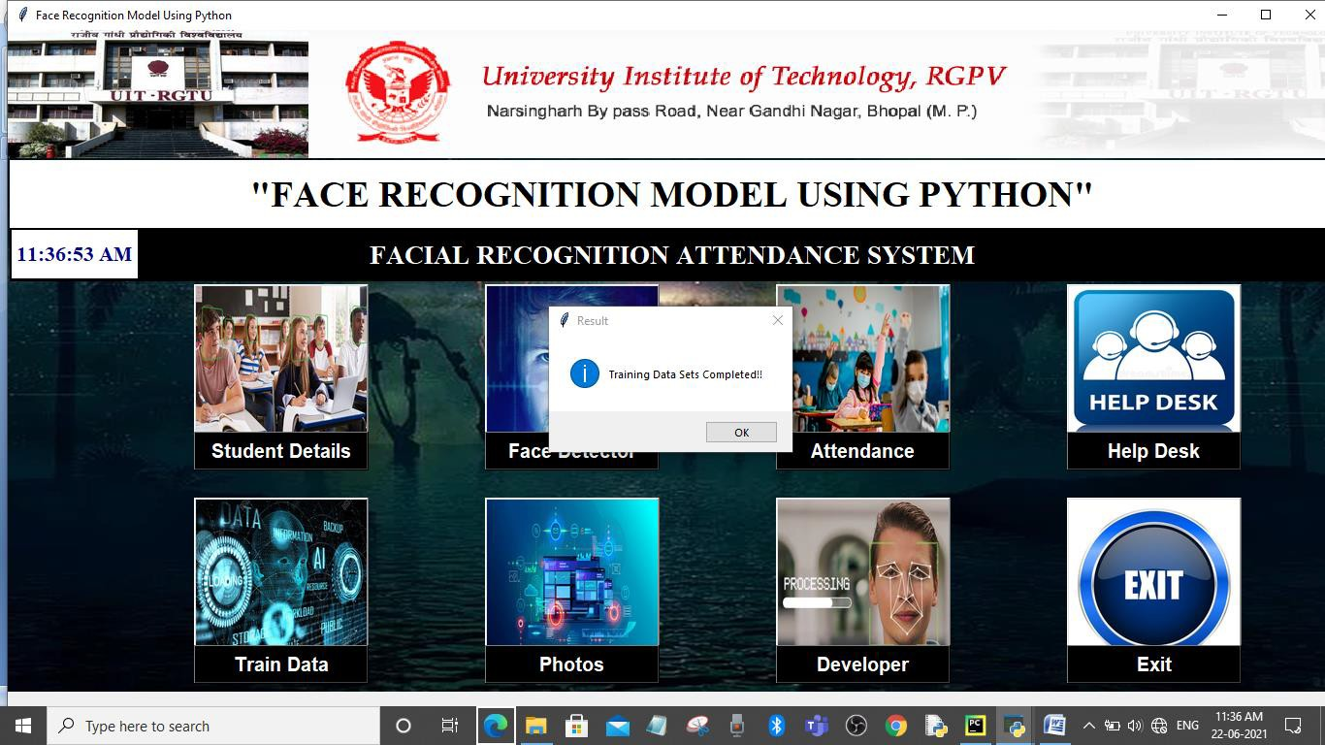

Fig.3.2.: Training Data Sets Completed

On clicking Photos button of the main interface :

We can see the images that were taken during filling the student’s data in the “data” folder linked in the python file as shown in Fig.4.

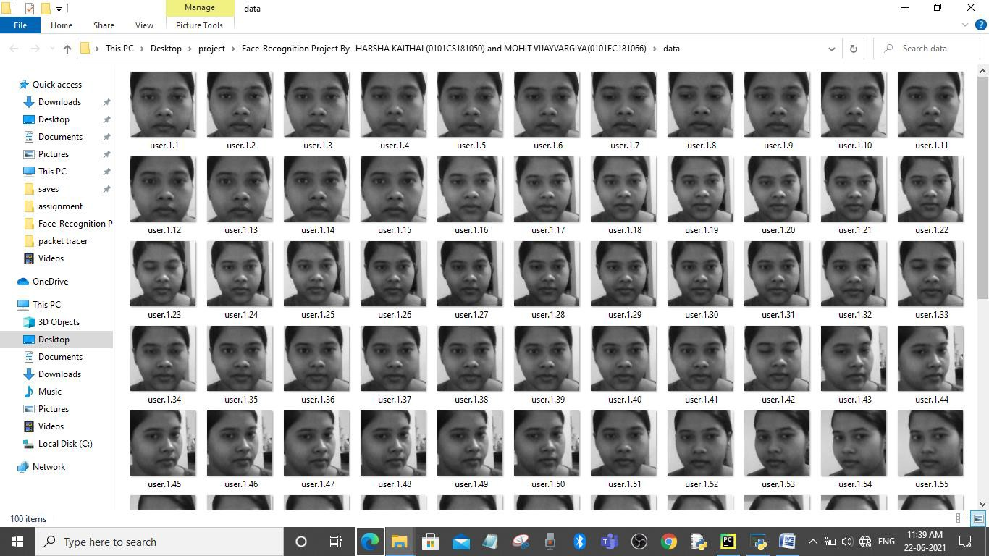

**Fig.4.: Folder Where Data Is Located**

On clicking Face Detector button on the main interface, we get the Face Recognition interface as shown below in Fig.5.:

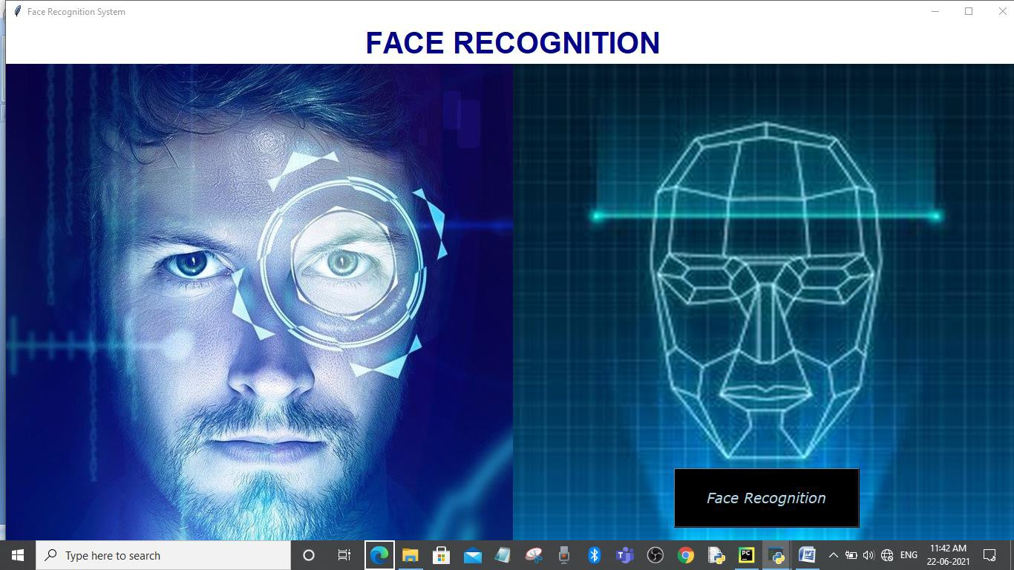

**Fig.5.:Face Recognition Interface**

On clicking Face Recognition, if the face of the student is matched then, the face will be recognized with the details filled and attendance would be stored in the database as shown in the Fig.5.1.

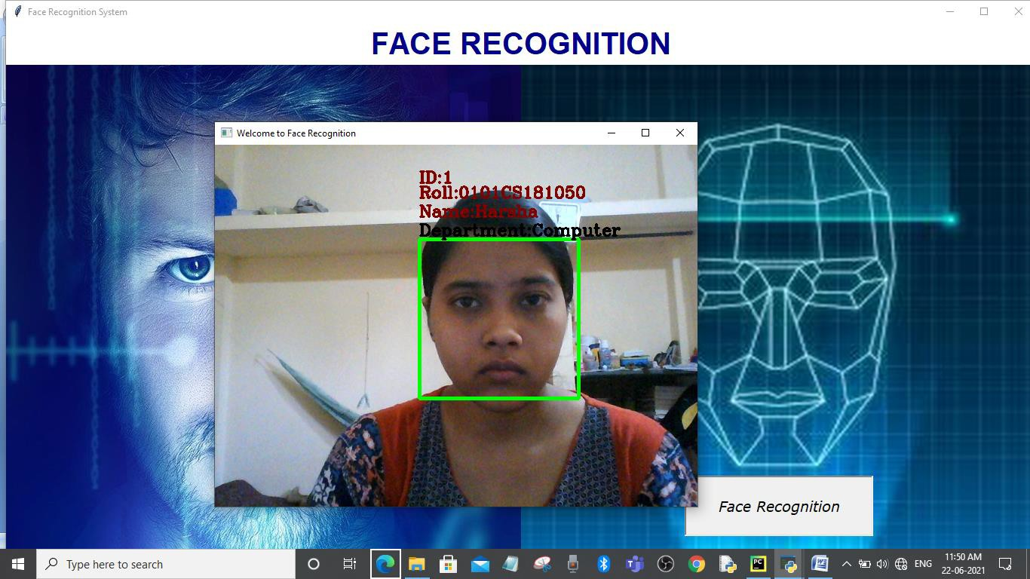

Fig.5.1.: Face Recognition with Students Details If Face Matched

If face is not matched i.e., not in the present, it will shown as “unknown face” while detecting.

Now clicking on Attendance button of the main interface :

We will get the screen shown below in the Fig.6. to where we can see the attendance taken at the time of face detection by importing “face_model_attendace” file which we have made for storing attendance.

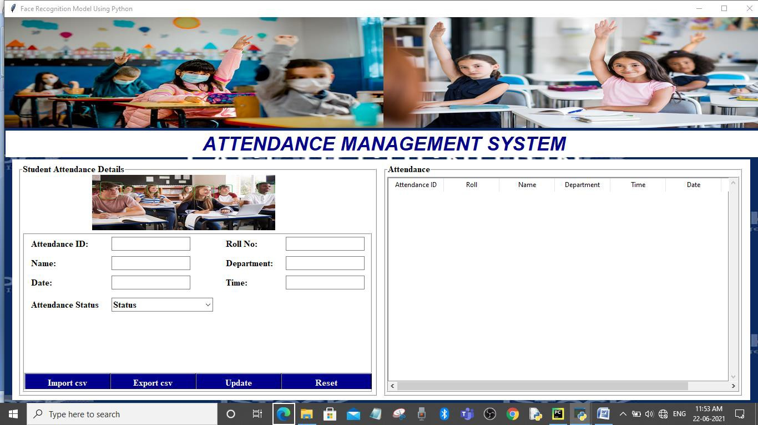

Fig.6.: Attendance Management System

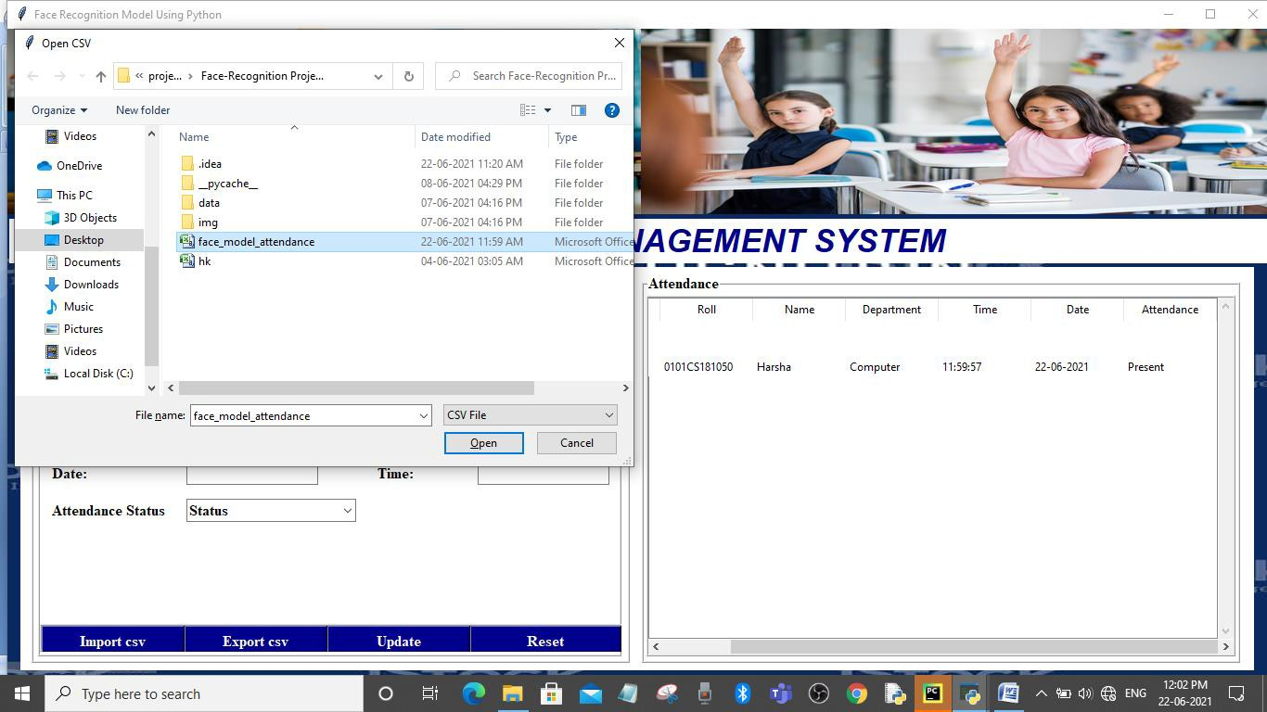

Fig.6.1.: File Where Attendance Is Saved

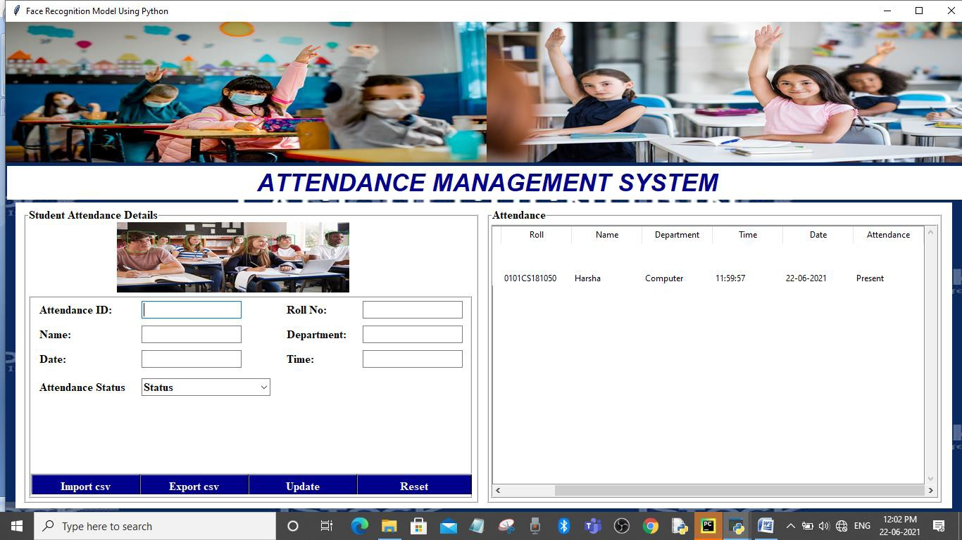

Fig.6.2: Display of Marked Attendance

Attendance details taken would be available at the Right-Hand Side table, which we can export also as another file.

Even we can Update the attendance details as the authorized person, after importing the file.

Now clicking on Developer button of the main interface. We can see the details of the developers as shown in the Fig.7.

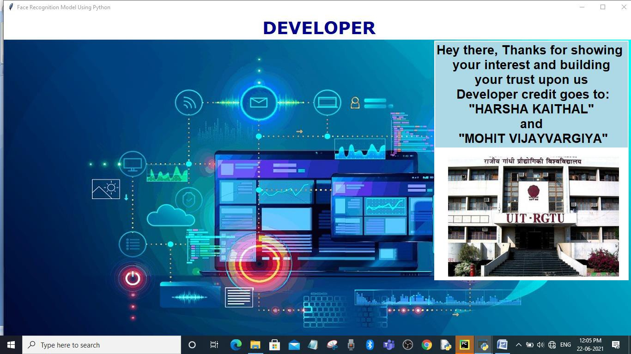

Fig.7.: Developer Credit Interface

Clicking on Help Desk of the main screen would take us to the helping desk as shown in the Fig.8. wherein you can drop the message for any help.

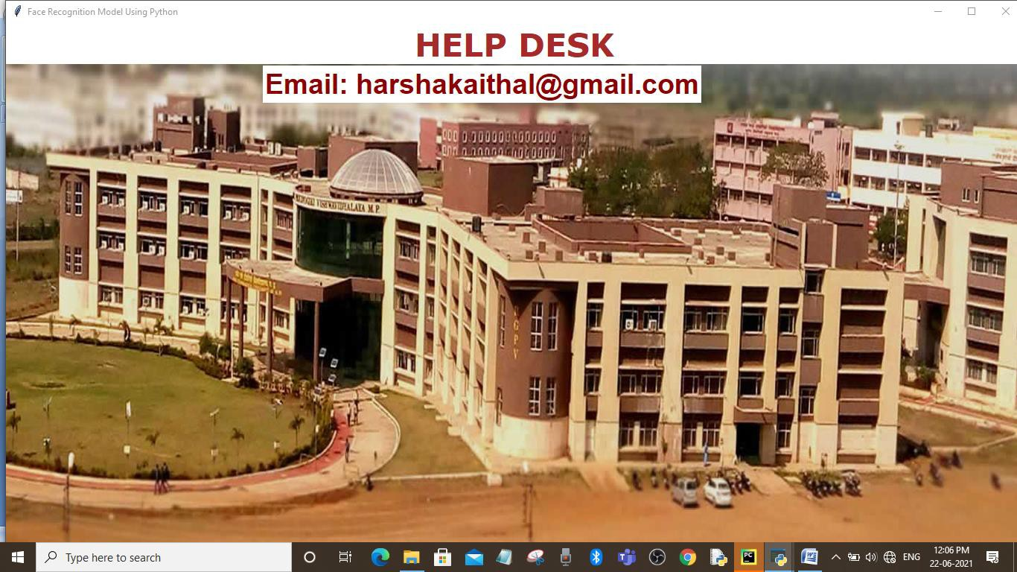

Fig.8.: Help Desk Interface

Now at last clicking on EXIT button of the main interface, the user is asked whether he/she wants to exit or stay on the same interface:

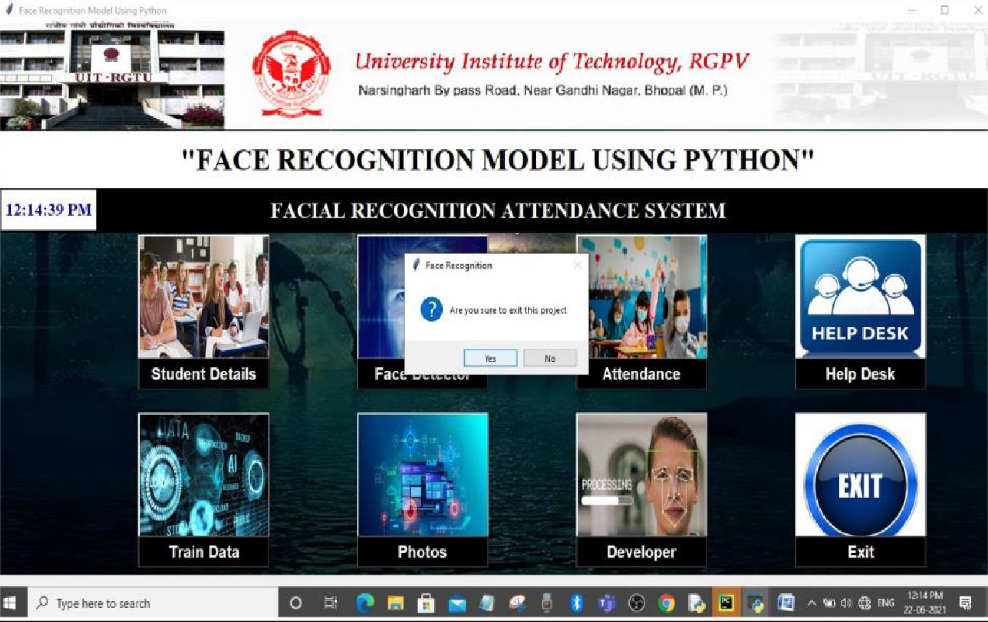

Fig.9. Procedure to Exit the Interface

If we press yes, we will be taken out of the project screen.

If we press no, we will remain in our main project screen.